**Object Oriented Programming Structure**

**Uses of “this” keyword**

1. “this” keyword can be used to refer current class instance variable.

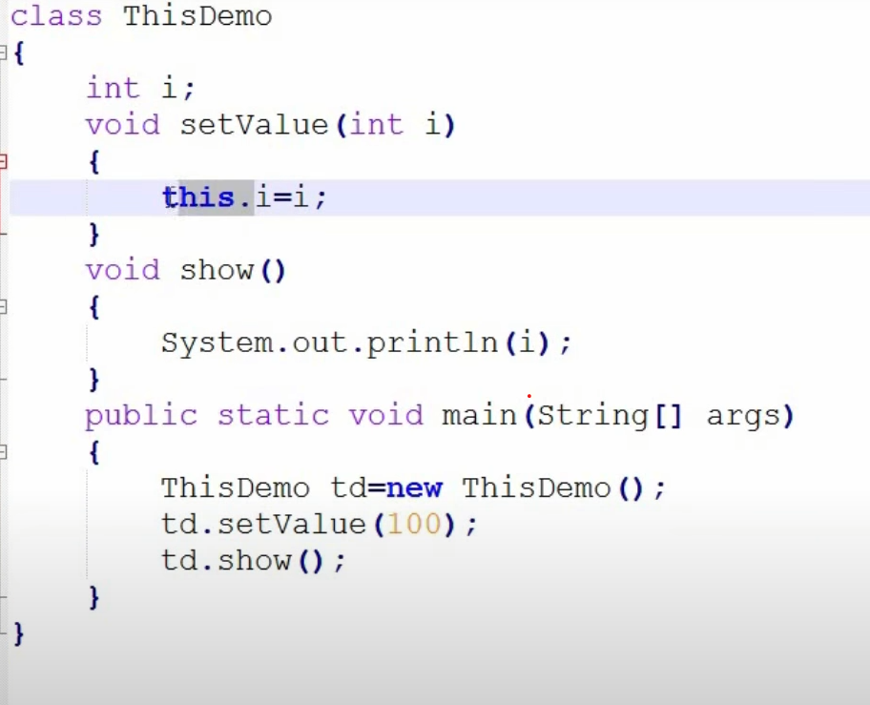

1. “this” keyword can be used to invoke current class method (implicitly).

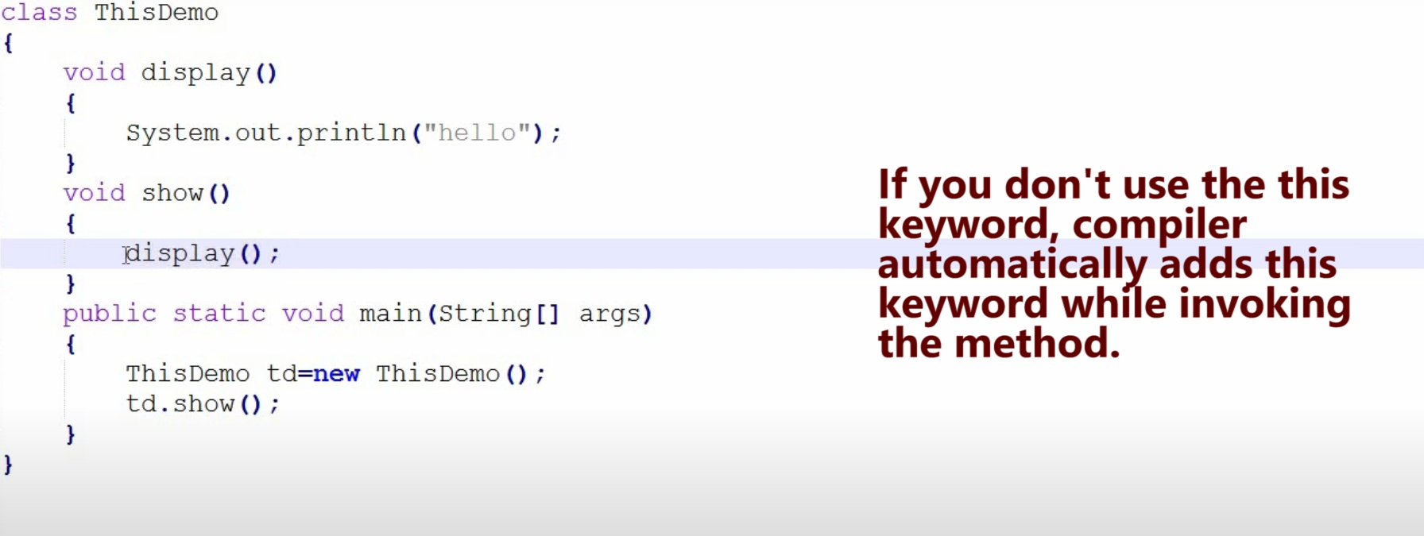

1. “this( )” can be used to invoke current class constructor.

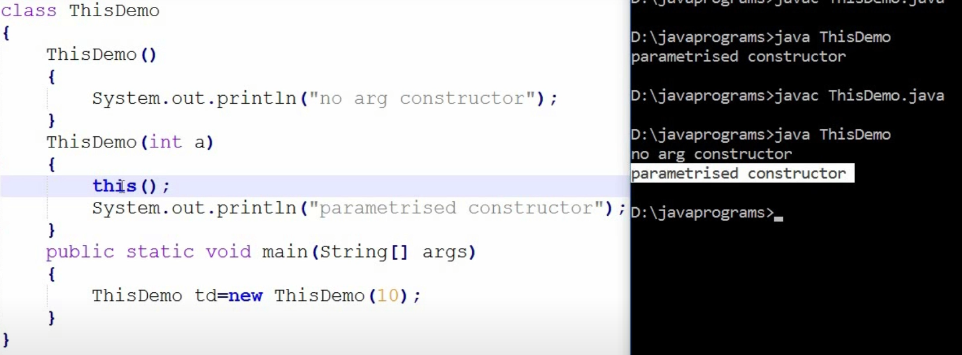

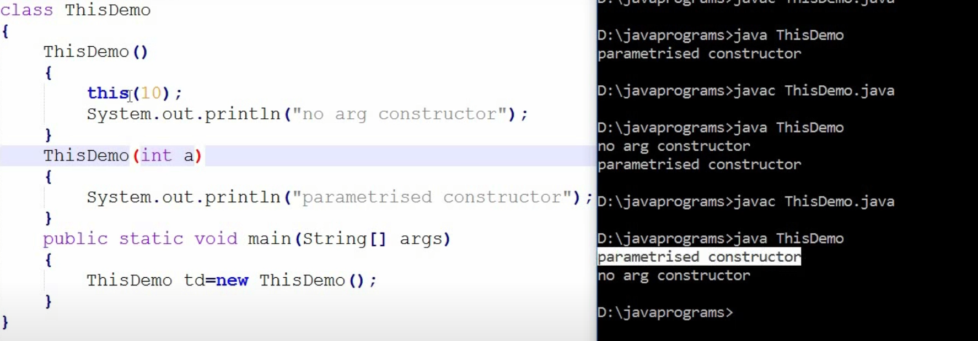

1. “this” can be used to pass as an argument in the method call.

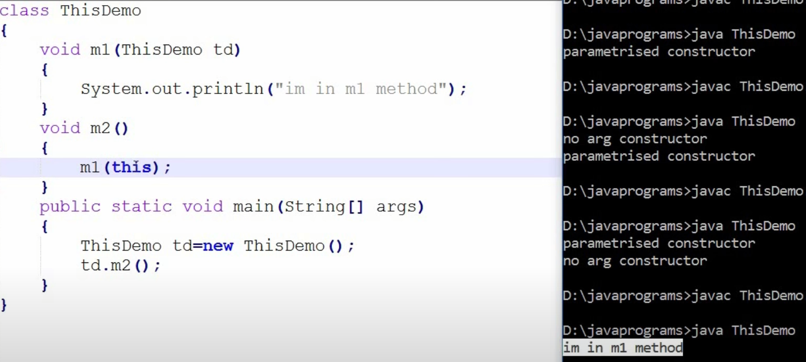

1. “this” can be used to pass as an argument in the constructor call.

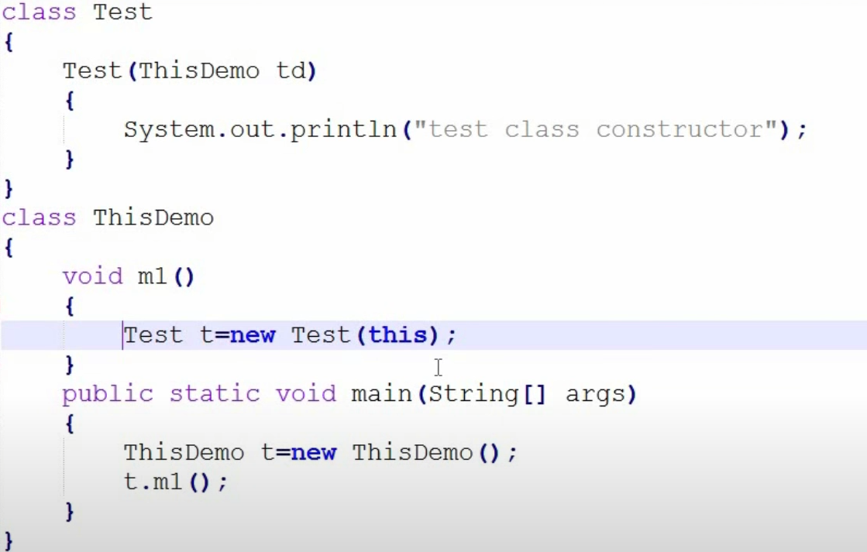

1. “this” can be used to return the current class instance from the method.

